Lab 03

Bipolar Junction Transistor (BJT) Characteristics
Name: Syed Sualeh Abbas, Muhammad Haider Zaidi | Student ID: 10303

Objective
To investigate the characteristics of Bipolar Junction Transistor and its input and output characteristic curves in Common Emitter configuration with load line.
The CLOs, LDLs and PLOs mapped on in this lab are:
CLO | Description | LDL | PLO
CLO 1 | Investigate characteristics of basic electronic devices and their application in development of electronic solutions. | Psy - 3 | PLO-4
CLO 3 | Apply appropriate techniques of OrCAD PSpice software for simulating electronic circuits. | Psy - 4 | PLO-5
CLO 4 | Demonstrate ethical values by complying with instructions and practicing punctuality and integrity | Aff - 3 | PLO-8

Note: All the plots required to be attached should be labeled properly, followed by Task number and must be readable, i.e., use white background, suitable marker color (recommended – any dark color) and increase the width of trace. On PSpice there is an option to add text labels in the plots.

Pre-Lab Task
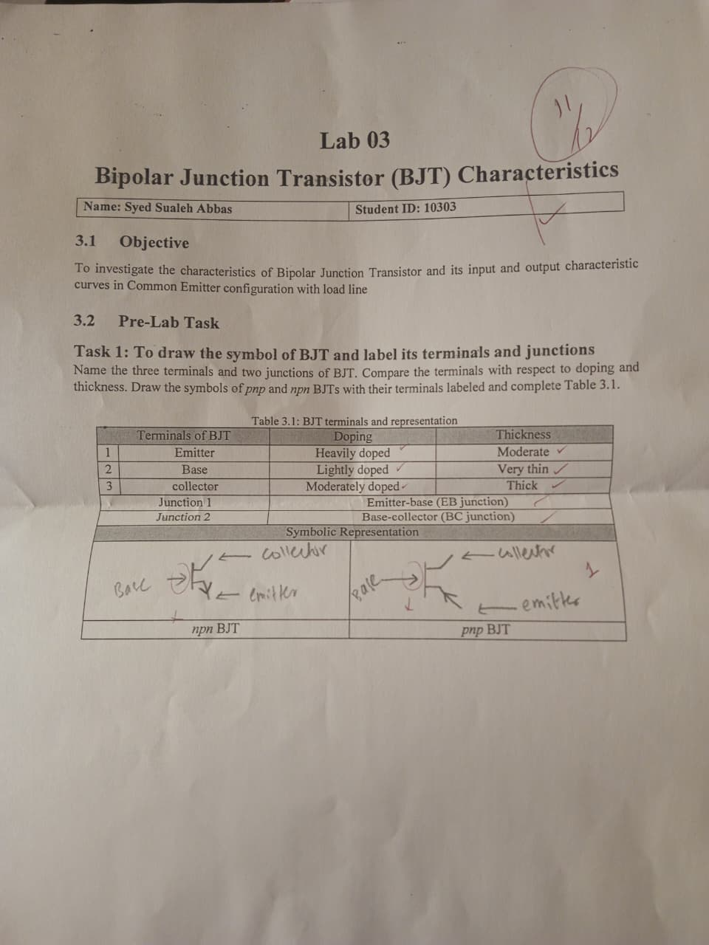

Introduction to Bipolar Junction Transistor
Bipolar transistors are made of either silicon (Si) or germanium (Ge). Their structure consists either of two layers of n-type material separated by a layer of p-type material (npn), or of two layers of p-material separated by a layer of n-material (pnp). In either case, the center layer forms the base of the transistor, while the external layers form the collector and the emitter of the transistor. The symbolic representation must have been obtained in Pre-Lab Task. Note that the arrow at the emitter terminal of the transistor symbol for either type of transistor points in the direction of conventional current flow and thus provides a useful reference. One part of this experiment will demonstrate how you can determine the type of transistor and its material, and identify its three terminals.
The relationships between the voltages and the currents associated with a bipolar junction transistor under various operating conditions determine its performance. These relationships are collectively known as the characteristics of the transistor which will be investigated in later part.

Modes of Operation
There are 3 modes of operation of a BJT as given in Table which are categorized by the biasing of the two junctions; emitter-base (EB) junction and collector-base (CB) junction.
Table 3.4 a: Modes of operation of BJT
Modes of Operation | Base-Emitter Junction | Base-Collector Junction
Cut-off Region | Reverse-Biased | Reverse-Biased
Saturation Region | Forward-Biased | Forward-Biased
Linear / Active Region | Forward-Biased | Reverse-Biased

For npn configuration the conditions for base emitter junction and base-collector Junction Voltages in Reverse and Forward bias mode would be as follows:
Table 3.5b: Modes of operation of BJT
Modes of Operation | Base-Emitter Junction |  | Base-Collector Junction
Cut-off Region | Reverse-Biased | $$V_{E}>V_{B}$$ | Reverse-Biased | $$V_{C}>V_{B}$$
Saturation Region | Forward-Biased | $$V_{B}>V_{E}$$ | Forward-Biased | $$V_{B}>V_{C}$$
Linear / Active Region | Forward-Biased | $$V_{B}>V_{E}$$ | Reverse-Biased | $$V_{C}>V_{B}$$

For pnp configuration the conditions for base-emitter junction Voltage and base-collector Junction Voltage in Reverse and Forward bias mode would be as follows:

Table 3.6 c: Modes of operation of BJT
Modes of Operation | Base-Emitter Junction |  | Base-Collector Junction
Cut-off Region | Reverse-Biased | $$V_{B}>V_{E}$$ | Reverse-Biased | $$V_{B}>V_{C}$$
Saturation Region | Forward-Biased | $$V_{E}>V_{B}$$ | Forward-Biased | $$V_{C}>V_{B}$$
Linear / Active Region | Forward-Biased | $$V_{E}>V_{B}$$ | Reverse-Biased | $$V_{B}>V_{C}$$

To investigate the operation of BJT in these regions and relation between voltage and current at its input and output terminals, we will use the most frequently used transistor configuration called common-emitter configuration as the emitter is common to both the input and output terminals (in this case common to both the base and collector terminals) as shown in Figure 3.2. Two sets of characteristics are necessary to describe fully the behavior of the common-emitter configuration: one for the input or base–emitter circuit and one for the output or collector–emitter circuit.
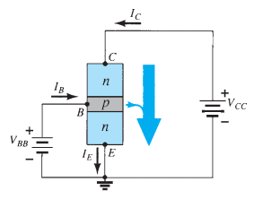
Figure 1: Common-emitter configuration
These characteristics are represented by obtaining VI curves i.e., base-current against base-emitter voltage (I_{B}-V_{BE} curve) and collector current against collector-emitter voltage (I_{C}-V_{CE} curve). When base-emitter junction gets forward biased, at a given base-emitter voltage a constant base-current is established. Output characteristics also called common-emitter characteristics i.e., plot of collector current against collector-emitter voltage, can represent the operation of BJT in different modes.
At small values of V_{CE}, the collector voltage is less than that of base causing CB junction to get forward biased. This causes the transistor to enter saturation region where both the junctions are forward biased. For a given base bias, increase in V_{CE} reduces the forward bias and eventually reverse bias the CB junction causing it to operate in active (linear) region. In this region, the collector current ideally should not increase once the CB junction becomes reverse biased. But practically due to early effect, the width of depletion region is affected by reverse biased voltage which increases the reverse saturation current. This makes the collector current to slightly increase at higher values of V_{CE} causing the characteristics to exhibit some slope.

Task 2: To investigate the input characteristics of 2N3904 npn-BJT using PSpice
Figure 3.3 shows 2N3904 npn transistor connected in common emitter configuration. Its input characteristics can be investigated through plot between base current I_{B} and base-emitter voltage V_{BE} at a given collector-emitter voltage.
Figure 3.3: BJT 2N3904 connected in common-emitter configuration
- Implement the circuit using OrCAD Capture. Set Vcc to 10 V which indicates that collector-emitter voltage is also set to 10 V as the source is directly connected to collector terminal.
- To obtain curve between base current and base-emitter voltage, the base current will be varied by varying the voltage of source Vbb. To do this, perform DC sweep analysis taking Vbb as sweep variable. Vary its voltage from 0 to 10 V at an increment of 0.1V.
- Run the simulation and obtain trace for base current. Set the x-axis variable to base-emitter voltage. Go to Axis Settings, X-Axis tab and change x-axis variable through the required expression e.g. V(Q1:B)-V(Q1:E).
- Attach the plot with suitable title and white background color. Analyze the input characteristics through obtained plots. Can you relate the plot with VI-characteristics of diode?

RELATION BETWEEN BASE-EMITTER VOLTAGE & BASE CURRENT
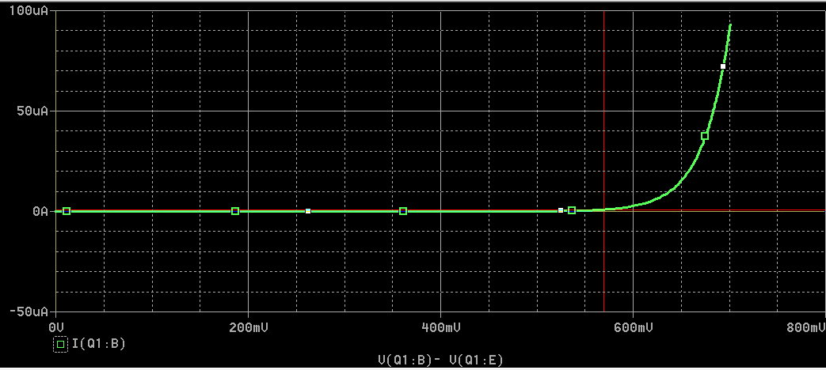
The obtained plot shows the variation of base current (I_B) with respect to base emitter voltage (V_BE) while keeping collector emitter voltage (V_CE = 10 V) constant. This represents the input characteristic of a BJT in common-emitter configuration.
From the graph, it is observed that for low values of V_BE, the base current remains almost zero. This indicates that the base emitter junction is not forward biased and the transistor is in the cut-off region. As V_BE increases beyond approximately 0.6 V, the base current starts increasing rapidly and nonlinearly. A small increase in V_BE results in a large increase in I_B, showing an exponential relationship.
This behavior is very similar to the V–I characteristics of a diode. The reason is that the base emitter junction of a BJT is a PN junction, just like a diode. When forward biased, it follows the diode equation, leading to an exponential rise in current after the cut-in voltage. small deviations from a diode curve are due to transistor specific effects such as base resistance.
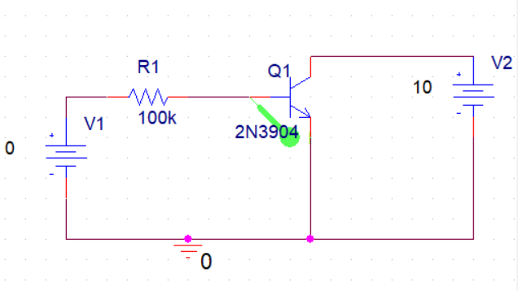

Task 3: To investigate the output characteristics of 2N3904 npn-BJT using PSpice
To investigate the output characteristics of BJT, collector current is plotted against collector-emitter voltage at different values of base current.
- Modify the circuit implemented in previous task. Initially set Vbb to 2.7 V. Create a new simulation profile and perform DC sweep analysis to vary collector to emitter voltage by selecting Vcc as primary sweep variable. Vary this voltage from 0 to 10V at an increment of 0.1V. Run the simulation to obtain trace for collector current I_{C} and make sure the x-axis variable is set to V_{CE} (e.g. V(Q1:C)-V(Q1:E)).
- From I_{C}-V_{CE} curve, identify the modes of operation of BJT and add suitable labels. Attach graph of the plot obtained with labels identifying the modes of operation and base current.
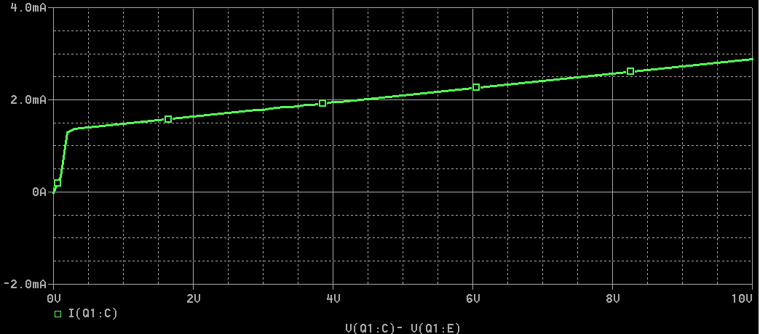
- Measure the base current also for which this plot is obtained. You can do this by adding trace for I_{B} in a separate window. Attach graph of the plot obtained with labels.

BASE CURRENT (1st Graph)
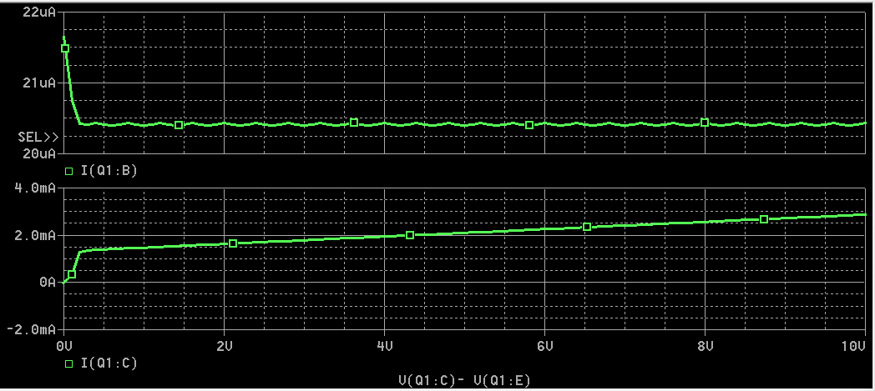
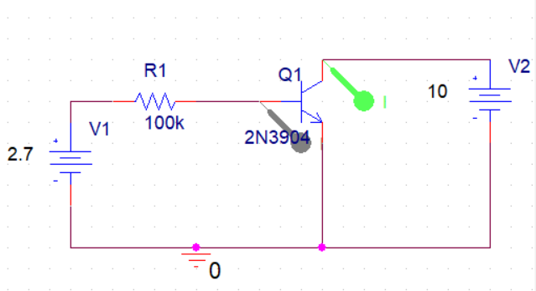
1. Saturation Region
At low values of V_CE (approximately 0–0.2 V), the collector current rises sharply with a small increase in V_CE. In this region, both the base–emitter and base–collector junctions are forward biased. The transistor is said to be in saturation, and it cannot maintain a constant collector current. This region is used when the transistor operates as a switch (ON state).
2. Active Region
As V_CE increases beyond the saturation voltage, the transistor enters the active region. In this region, I_C remains almost constant despite an increase in V_CE, as seen by the nearly horizontal portion of the curve. Here, the base–emitter junction is forward biased while the base–collector junction is reverse biased. The collector current is mainly controlled by the base current (set by Vbb), making this region suitable for amplification.
3. Cut-off Region
Although not clearly visible in this plot (because Vbb is sufficiently high), the cut-off region corresponds to very small or zero collector current when the base current is nearly zero. In this region, both junctions are reverse biased and the transistor is in the OFF state.

- Now, to investigate the effect of base current on this relation, the same primary sweep will be performed for different values of base current. To do this, edit simulation settings and check the secondary sweep option. Take Vbb as secondary sweep variable with its value ranging from 0.7V to 10.7V at an increment of 2V.
- Run the simulation and obtain I_{C}-V_{CE} curves. With each curve label the corresponding base current. Attach graph of the plot obtained with labels.
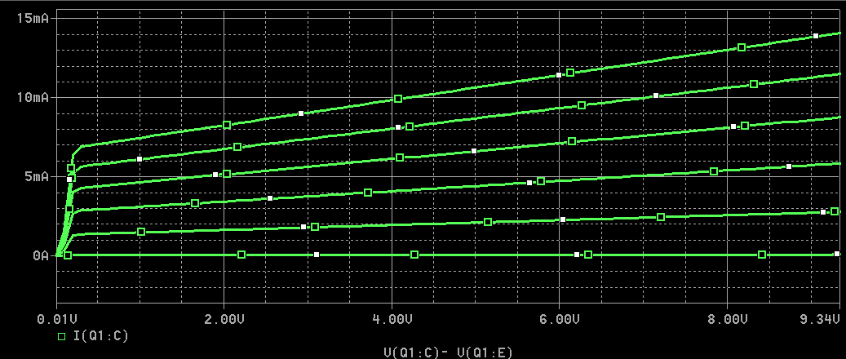

- What is effect of increasing base current on the obtained collector current curves?
Effect of Increasing Base Current:
As the base current increases, the collector current (Ic) increases proportionally for a given collector-emitter voltage (Vce). This is evident from the family of curves, where each successive curve (moving upward) represents a higher base current level. The curves show that the transistor operates in the active region, where Ic is primarily controlled by the base current, demonstrating the current amplification property of the BJT. The relatively flat nature of the curves in the active region indicates that collector current remains nearly constant for varying Vce at a fixed base current, with the spacing between curves representing the current gain (β) of the transistor.

- Analyze the relation between collector current with collector to emitter voltage in each mode of operation?
Analysis of Ic vs Vce Relationship in Different Operating Modes:
The collector current exhibits distinct behavior across different operating regions. In the cut-off region, represented by the bottom curve where base current is approximately zero, the collector current remains nearly zero regardless of the collector-emitter voltage, indicating the transistor is OFF.
In the saturation region, occurring at low Vce values (typically below 0.5V), the collector current rises steeply as both junctions become forward biased, and the transistor behaves like a closed switch.
As Vce increases beyond the saturation region, the transistor enters the active region where the curves flatten out and become nearly horizontal. In this region, the collector current remains relatively constant for a given base current despite variations in Vce, demonstrating that Ic is primarily controlled by the base current. This flat characteristic in the active region is essential for amplification applications, as it allows the transistor to maintain stable current gain across varying load conditions.

- Does collector current remain constant in active region? What would have been the ideal behavior?
Collector Current Behavior in Active Region:
No, the collector current does not remain perfectly constant in the active region. As observed in the characteristic curves, there is a slight upward slope in each curve as Vce increases, indicating a gradual increase in collector current with increasing collector-emitter voltage. This non-ideal behavior is primarily due to the Early effect (base-width modulation), where increasing Vce causes the collector-base depletion region to widen, effectively reducing the base width and increasing the current gain.

Ideal Behavior:
Ideally, the collector current should remain perfectly constant in the active region for a fixed base current, resulting in completely horizontal characteristic curves. In an ideal transistor, Ic would depend only on the base current (Ic = β × Ib) and would be independent of Vce. This would yield infinite output resistance, making the transistor a perfect current source controlled solely by the base current. However, real transistors exhibit finite output resistance due to the Early effect, resulting in the slight positive slope observed in practical characteristic curves.

DC Current Gain
In DC mode, the levels of I_{C} and I_{B} for any transistor are related by a quantity called beta and defined by the following equation:
Where, I_{C} and I_{B} are determined at a particular operating point on the characteristics. For practical devices the level of β typically ranges from about 50 to over 400. This gain reveals the relative magnitude of collector current with respect to the base current. On specification sheet, it is usually included as h_{FE}.

Task 4: To analyze variation in DC current gains with collector-emitter voltage and base current
- From the plots obtained in previous task, through cursors measure the collector current at two given points of each curve; when V_{CE} is 2V and when it is 10V. Record your measurements in Table 3.7 and mention corresponding base current.
Table 3.7: Data collection for DC current gain and its calculated values
Base Current: I_{B} (μA) | Collector-Emitter Voltage: V_{CE}=2V |  | Collector-Emitter Voltage: V_{CE}=10V
Base Current: I_{B} (μA) | I_{C} (mA) | β | I_{C} (mA) | β
99.98 | 8.25 | 82.51 | 14.616 | 146.18
80.03 | 6.744 | 84.26 | 11.931 | 149.08
60.11 | 5.139 | 85.49 | 9.0778 | 151.02
40.22 | 3.428 | 85.23 | 6.049 | 150.39
20.43 | 1.633 | 79.93 | 2.877 | 140.82

- Calculate the DC gain β for each. Is there any variation in DC current gain as we move from left to right on the curve?

Yes, there is clear variation in the DC current gain. The β values increase substantially as Vce increases from 5V to 10V, with an average increase of approximately 70-75%. This variation is primarily attributed to the Early effect, where higher collector-emitter voltages cause base-width modulation, resulting in increased current gain. Additionally, there is slight variation in β at different base current levels within the same Vce, though this is less pronounced. This non-ideal behavior demonstrates that β is not strictly constant but depends on the operating point of the transistor, particularly the collector-emitter voltage.

- This current gain β is the property of transistor and does vary by temperature as well. Go through the datasheet of 2N3904 BJT (https://www.onsemi.com/pub/Collateral/2N3903-D.PDF) and observe how this para meter is specified in the datasheet. The AC current gain is specified as h_{fe} in the datasheet (with small letters in subscript) which is something different than the DC gain. The curve shown in Figure 15 of datasheet illustrates the effect of temperature on h_{FE}. Analyze it briefly.
The DC current gain (hFE) of the 2N3904 transistor depends on the collector current (IC), collector-emitter voltage (VCE), and temperature. As temperature rises, hFE increases due to enhanced carrier injection. However, hFE decreases at very high or very low collector currents. The Early effect slightly increases hFE at higher VCE values. Therefore, transistor circuits should be designed while considering temperature variations, as hFE is not a constant parameter.

Task 5: To investigate the change in operating point with the help of load line
The collector current together with collector to emitter voltage (Ic, V_{CE}) specifies operating point of transistor. The operating point is a fixed point on the characteristics; it is also called the quiescent point (Q -point). It is interesting to note that because the base current is controlled by the level of R_{B} and I_{C} is related to I_{B} by a constant β, the magnitude of I_{C} is not a function of the resistance R_{C}. Changing R_{C} to any level will not affect the level of I_{B} or I_{C} as long as we remain in the active region of the device. However, as we shall see, the level of R_{C} will determine the magnitude of V_{CE}, which is an important parameter.
- To verify this, connect a 1k Ω resistor at collector terminal of transistor. Set V_{bb} of 2.7V and V_{CC} at 10V. Simulate the circuit and obtain collector-to-emitter voltage and collector current and note down in Table.
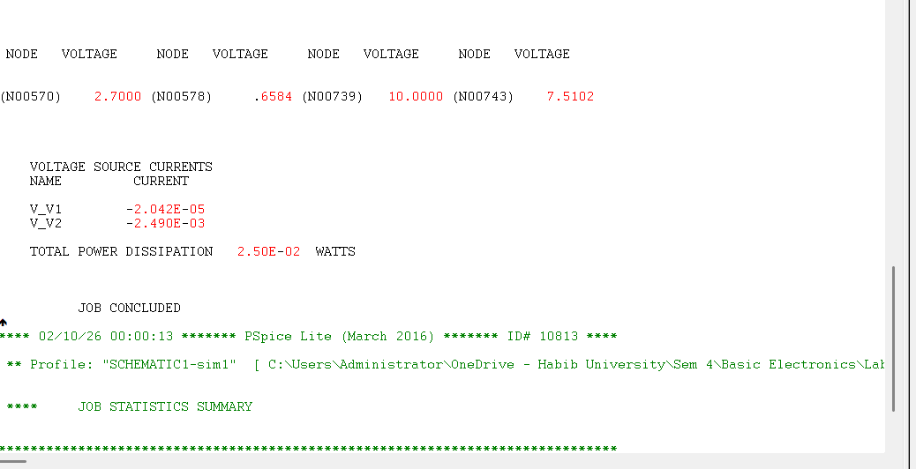
Table 3.8: Operating point of BJT with 1k Ohm load resistor
Collector-Emitter Voltage: V_{CE} | 7.51V
Collector Current: I_{C} | 2.49mA

- To directly obtain the operating point of transistor for a given load resistor and supply voltage V_{CC,} a load line can be plotted over the characteristic curves. The Ic-V_{CE} characteristics curves obtained in Task 3 for different values of base current can be used to find operating point by adding load line. Remove the 1kΩ from circuit and through Primary and Secondary Sweep obtain Ic-V_{CE} curves as done in Task 3 (or, re-use previously created simulation profile).
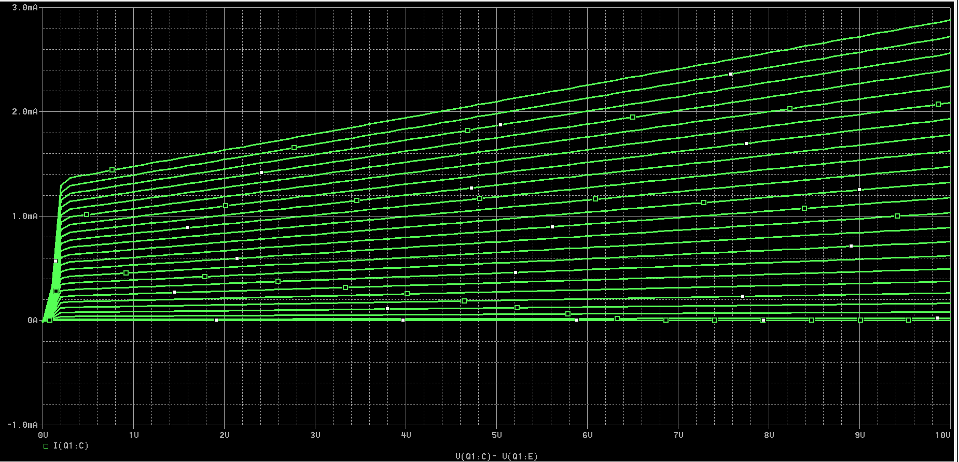

- To add a load line for 1kΩ load resistor R_{C}, add a trace with expression (10-V(Q1:C))/1000, which is PSpice trace expression for at fixed 10V Vcc and 1kΩ load resistor Rc when V_{CE} is being varied due to change in Ic as base current is varied. The intersection of the obtained load line with each characteristic curve gives the operating point of transistor for the corresponding base current. Note that instead of V_{CE}, collector voltage is used in PSpice trace expression as emitter is directly grounded.

- You can verify that the operating point found in Table 3.8 is the intersection point of load line and the Ic-V_{CE} curve at base current of 20μA. Attach the obtained plot and state your observations in the box below:
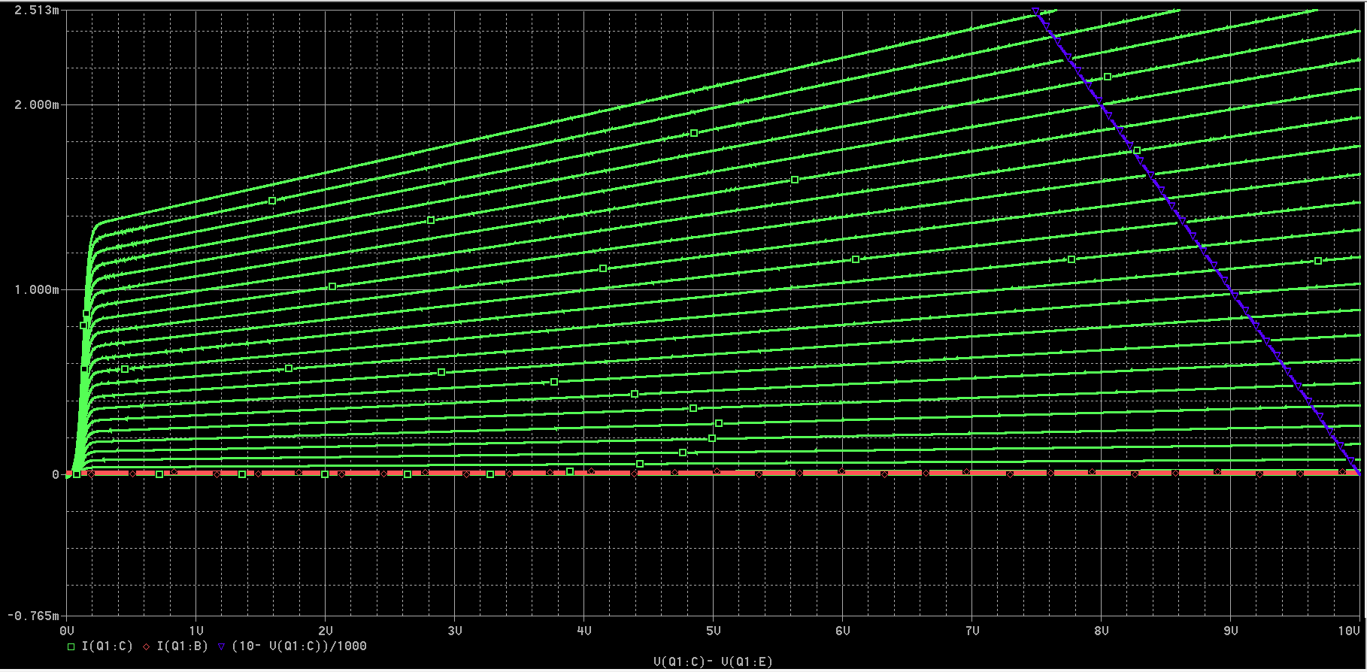
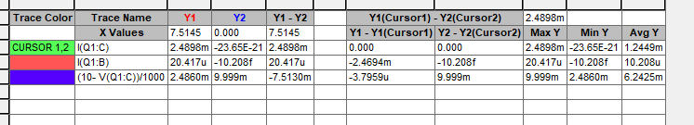
by examining the intersection points between the load line and the characteristic curves, we can verify the operating point. Based on the DC bias point analysis from Table 3.8 (IC = 2.49mA, VCE = 7.51V), the corresponding Q-point should lie on one of the middle characteristic curves at IB ≈ 20μA.

- To find the effect of varying load resistor, add another trace of load line with Rc of 2kΩ. Attach the capture of obtained plots with two load lines; one with 1kΩ and other with 2kΩ resistor. State your observations in the box below:
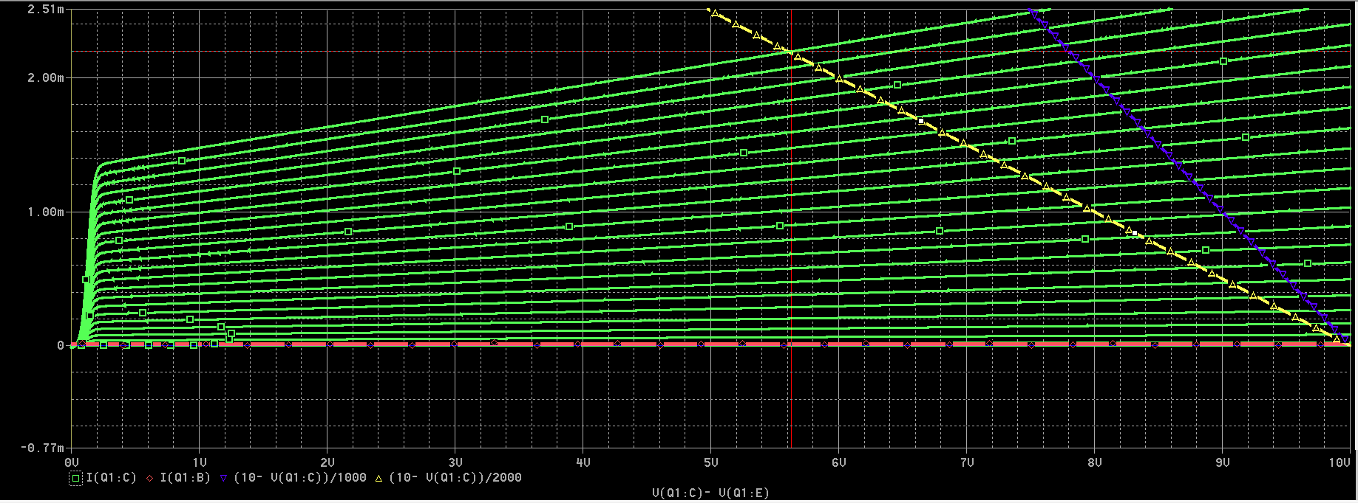
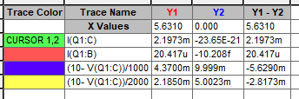
Load Line Comparison:
1kΩ Load Line (Blue):
- Extends from saturation point (VCE = 0V, IC = VCC/RC = 10V/1kΩ = 10mA) to cutoff point (VCE = 10V, IC = 0mA)
- Steeper slope: -1/RC = -1/1000 = -0.001
- Higher maximum collector current capability
2kΩ Load Line (Yellow):
- Extends from saturation point (VCE = 0V, IC = VCC/RC = 10V/2kΩ = 5mA) to cutoff point (VCE = 10V, IC = 0mA)
- Shallower slope: -1/RC = -1/2000 = -0.0005
- Lower maximum collector current capability
- Both lines pass through the common point (VCC, 0) = (10V, 0mA)
Effect of Increasing Load Resistor (RC):
From the cursor data, at VCE = 5.63V:
- 1kΩ load line: IC ≈ 2.48mA
- 2kΩ load line: IC ≈ 2.19mA
Varying the load resistor RC changes the operating point position along a given characteristic curve but does not change the transistor's intrinsic behavior. The load resistor determines the circuit constraint (load line), while the base current determines which characteristic curve the transistor operates on.

- Now, to find the impact of varying supply Vcc, remove the load line for 2kΩ and add another load line with trace expression having 20V Vcc. Attach the capture of plot.

- Analyze the impact of base current I_{B}, supply voltage Vcc and load resistor Rc on the operating point of transistor.
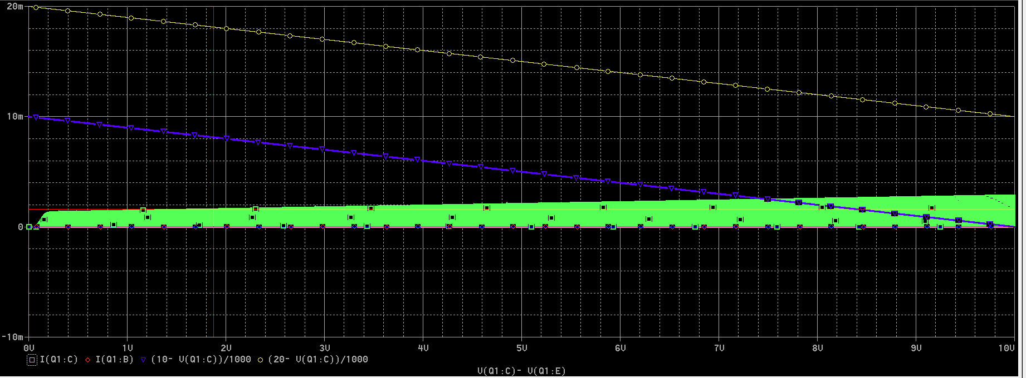
Effects of Increasing IB:
- Q-point moves upward and leftward along the fixed load line
- Collector current (IC) increases linearly (IC = β × IB, where β is transistor gain)
- Collector-emitter voltage (VCE) decreases due to larger voltage drop across RC
- Relationship: VCE = VCC - (IC × RC)
- Transistor transitions from cutoff region through active region toward saturation
Parallel Shift:
- Both load lines have identical slopes since RC is the same (1kΩ)
- The 20V load line is a parallel outward translation of the 10V line
- Both lines would intersect if extended backward, meeting at the origin conceptually
Effect on Operating Range:
- The 20V supply doubles the maximum collector current capability (from 10mA to 20mA)
- The cutoff voltage doubles from 10V to 20V
- The active region is significantly expanded, providing much greater operational space
Effect on Q-Point (for same IB):
- For any given base current (same characteristic curve):
  - Collector current remains approximately the same (minimal change)
  - VCE increases substantially (approximately doubles)
  - Q-point shifts horizontally to the right along the characteristic curve

Assessment Rubric
Lab 03
Bipolar Junction Transistor (BJT) Characteristics
Name: | Student ID:

Points Distribution

Task No. | LR2  Simulation | LR 4  Data Collection | LR5  Plots | LR 6  Calculation | LR 10  Analysis
Task 1 | - | - | /8 | - | -
Task 2 | /4 | - | /4 | - | /4
Task 3 | /8 | - | /8 | - | /8
Task 4 | - | /8 | - | /8 | /4
Task 5 | /8 | /4 | /8 | - | /8
 | /20 | /12 | /28 | /8 | /24
CLO Mapped | CLO 1 | CLO 1 | CLO 1 | CLO 1 | CLO 1

Affective Domain Rubric |  | Points | CLO Mapped
AR 3 | Pre-Lab Submission | 4 | CLO 1
AR 4 | Report Submission | 4 | CLO 1

CLO-(LDL) | Total Points | Points Obtained
CLO1 – (Psy-3) | 100
Total | 100

For description of different levels of the mapped rubrics, please refer the provided Lab Evaluation Assessment Rubrics and Affective Domain Assessment Rubrics.

